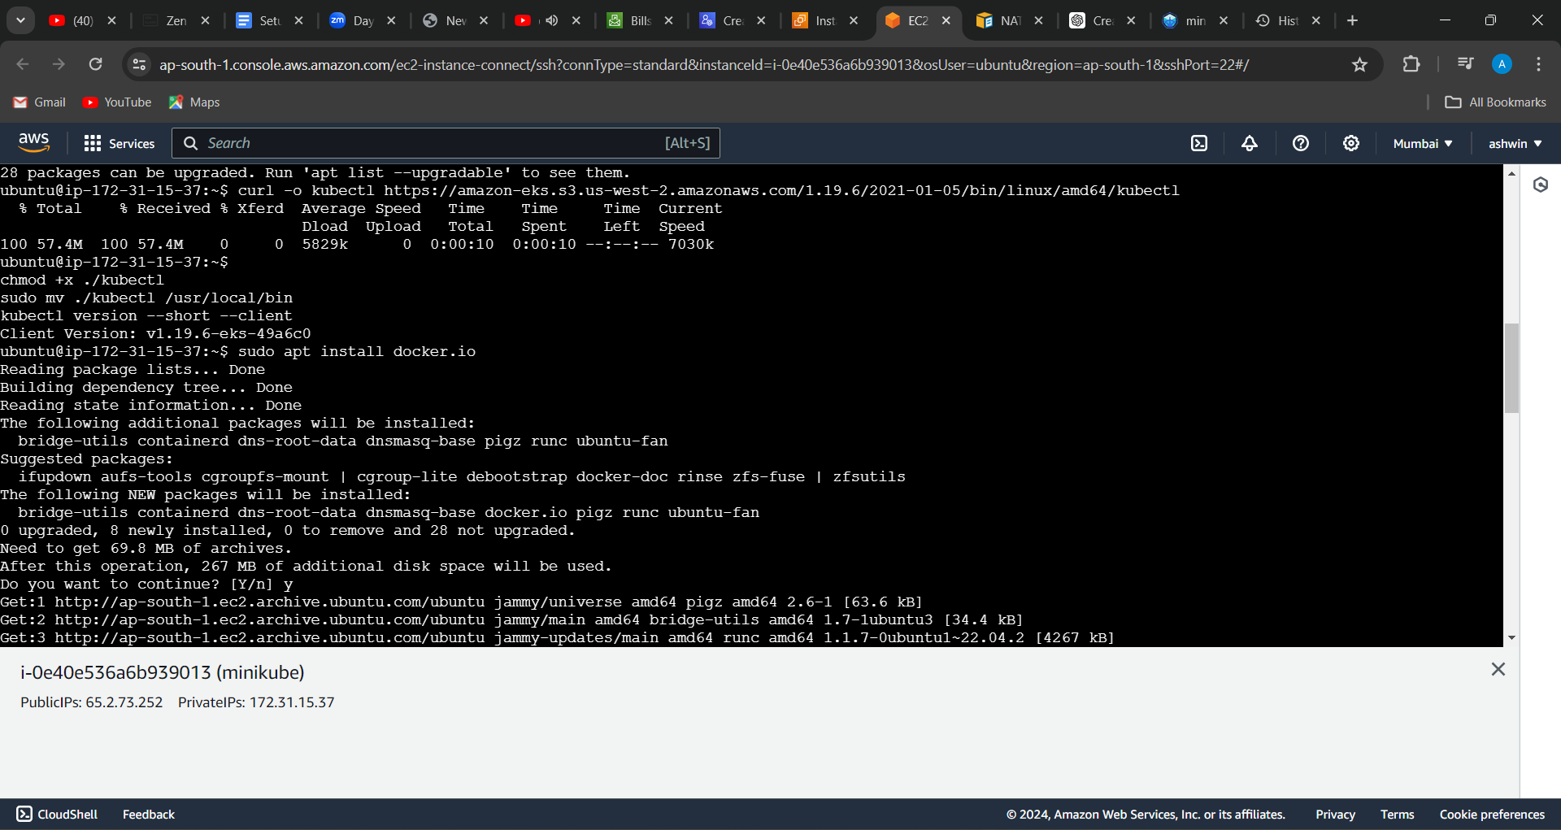

1(installed kubectl and docker)

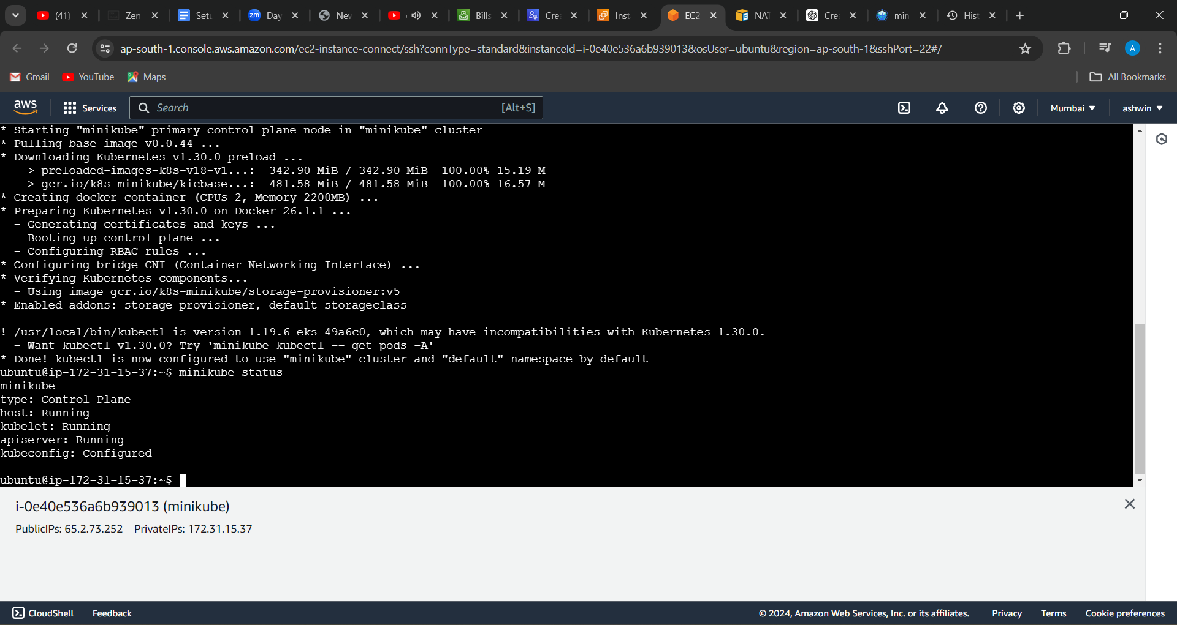

2(installed minikube and checked status)

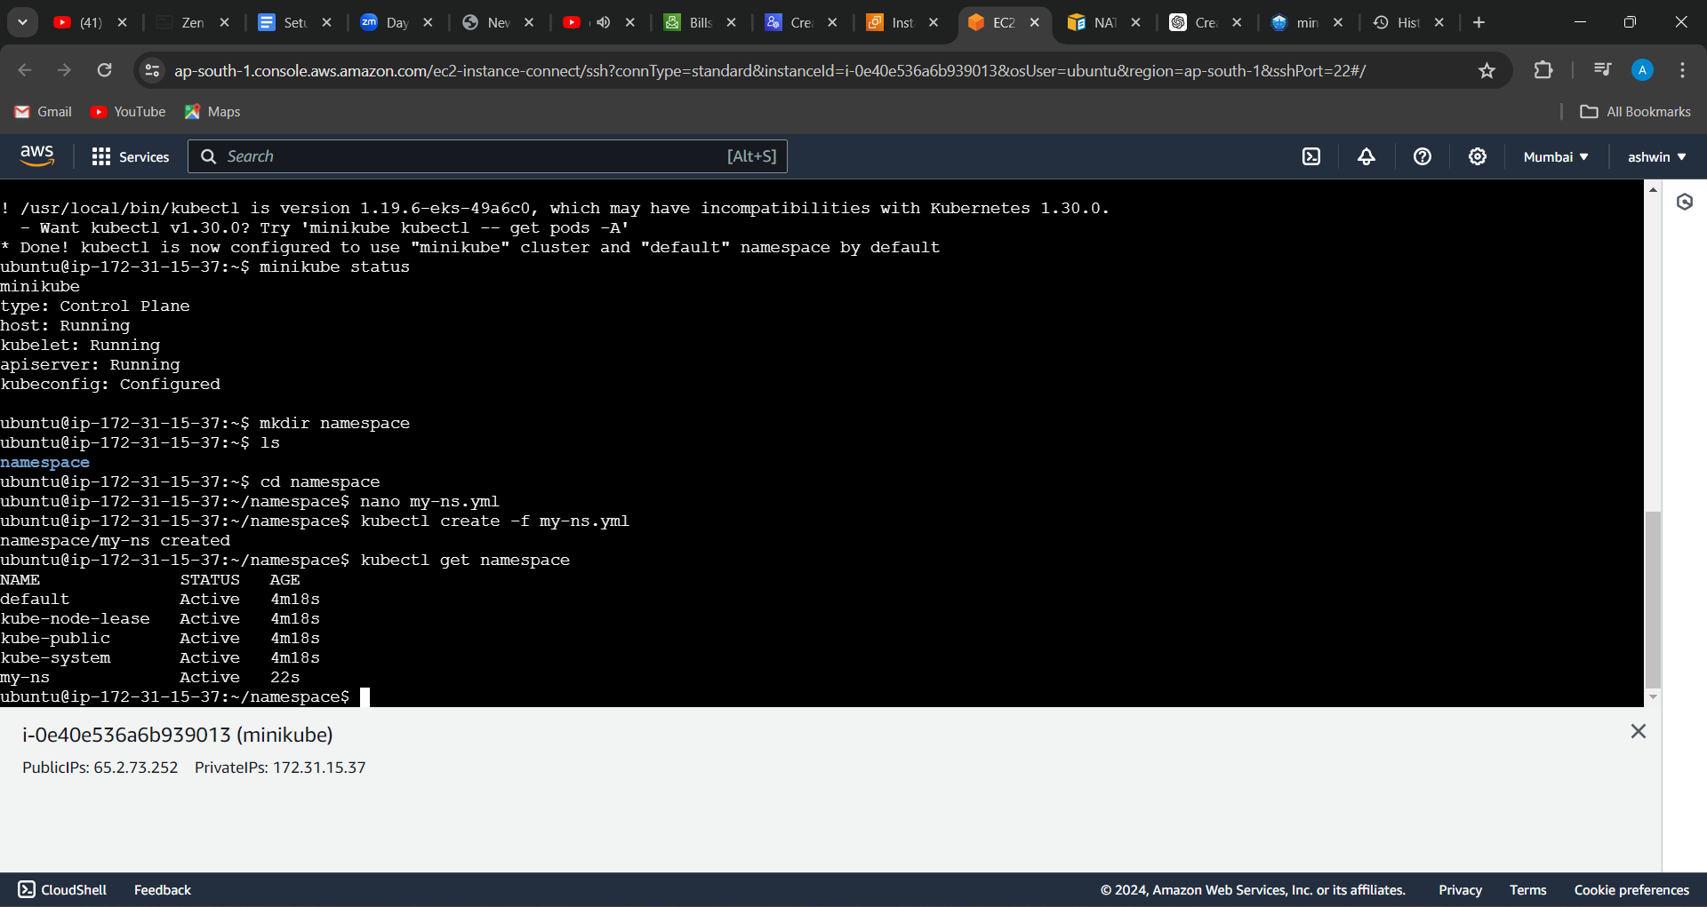

3(created a namespace and listed namespaces)

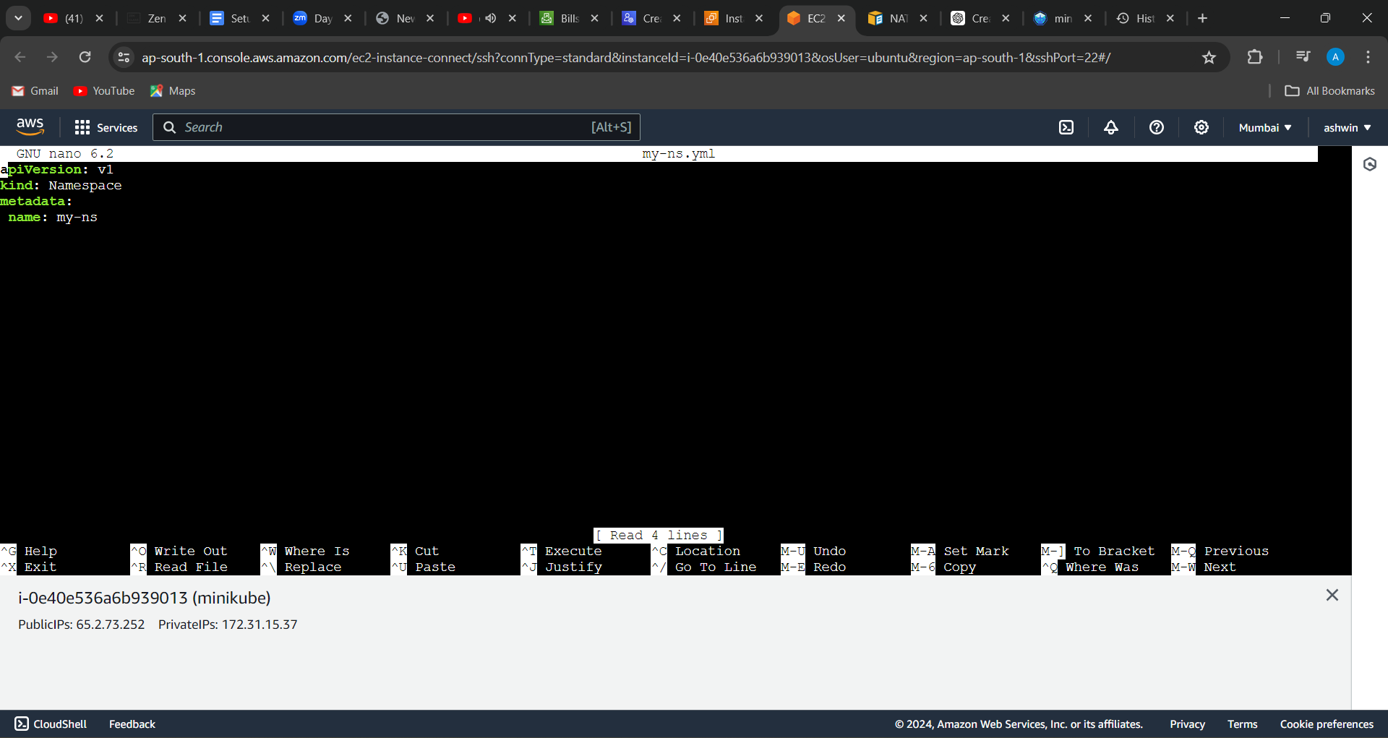

4(script for namespace)



5(stoped minikube)